PRESCRIBING in ACUTE OTITIS MEDIA in CHILDREN under 18 years
Audit Template

1. TOPIC

Antibiotic prescribing for acute otitis media in children under 18 years

2. PROFESSIONAL COMPETENCE DOMAINS

Clinical Skills
Management
Patient Safety and Quality of Care

3. OBJECTIVE

To audit antibiotic prescribing for acute otitis media against NICE Guideline CG91 : Otitis media (acute) : antimicrobial prescibing.

4. GUIDELINES

Evidence suggests that antibiotics are generally not required as first line treatment for acute otitis media (AOM). (1) (2)

The 2018 NICE guideline recommends the following :

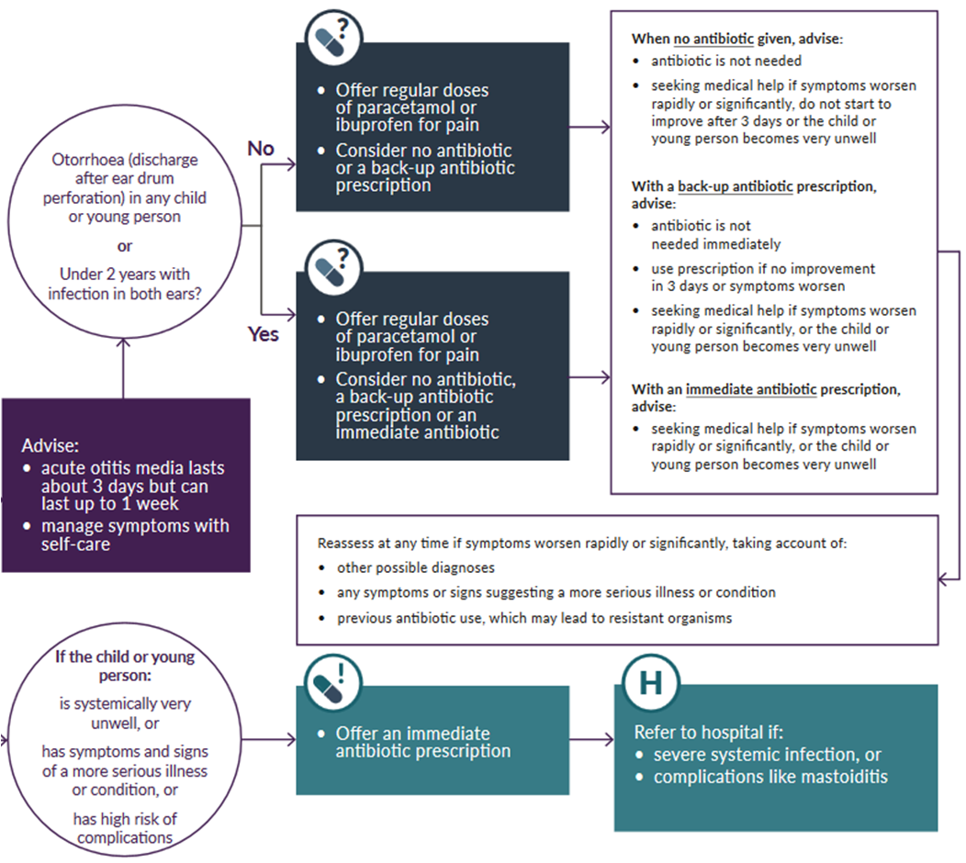

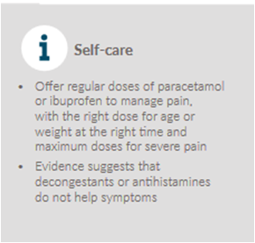
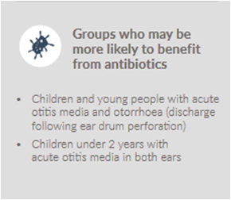

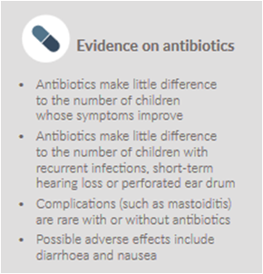

The 2017 Public Health England (PHE) Management of infection guidelines provide recommended antibiotic(s), dose, frequency and duration (3).

5. CRITERIA and TARGETS

- MANAGEMENT DECISION / TREATMENT
  - No antibiotic given (Target : >50%)
  - Back-up/delayed antibiotic given with advice about how to access (Target : <30%)
  - Immediate antibiotic given with advice on compliance (Target : <20%)

- GIVING ADVICE
  - Advice given on natural history and average length of illness 8 days (Target : 100%)
  - Advice given about managing symptoms including fever (self-care advice) (Target : 100%)
  - Information about when to re-consult (safety netting advice) (Target : 100%)
  - Information shared on antibiotic use and resistance (Target : >50%)
ANTIBIOTIC PRESCRIBING

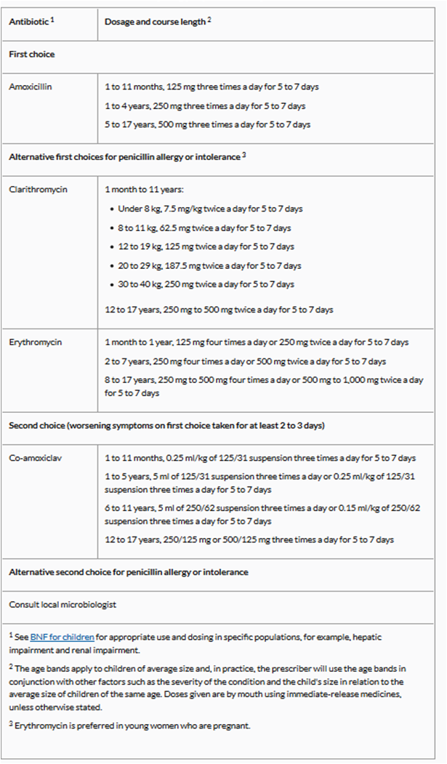

6. FIRST DATA COLLECTION (practice before audit)

Sample size : 30 consultations for acute otitis media in children under 18 years

Search your records for 30 past consultations for AOM in children under 18 years.

Enter the required data either in the Word Manual template for the First Data Collection
- Data about compliance with the criteria is entered manually and percentage of targets achieved is calculated manually
or in the Excel Automated template for the First Data Collection.
- Compliance with the criteria and percentage of target achieved are calculated automatically.

7. FIRST DATA ANALYSIS and INTERPRETATION
Analyse the data and interpret the results.

8. CHANGES IMPLEMENTED
Identify changes required to comply with the guidelines and meet the targets set for each criteria.

9. SECOND DATA COLLECTION (practice after improvements implementation)

Sample size : 30 consultations for acute otitis media in children under 18 years

Implement the changes in a further 30 consultations for AOM in children under 18 years.

Enter the required data either in the Word Manual template for the Second Data Collection.
- Data about compliance with the criteria is entered manually and percentage of targets achieved is calculated manually
or in the Excel Automated template for the Second Data Collection.
- Compliance with the criteria and percentage of target achieved are calculated automatically.

10. SECOND DATA ANALYSIS and INTERPRETATION
Analyse the data and interpret the results.

11. CONCLUSION
Draw appropriate conclusions from completion of the audit..

12. REFLECTIONS
Reflect on the experience of the audit and its impact on your professional life and practice..

13. REFERENCES
​
1. Otitis media (acute): antimicrobial prescribing
National Institute for Health and Care Excellence
NICE Guidance NG 91
Published : March 2018
Access

2. Antimicrobial stewardship: systems and processes for effective antimicrobial medicine use
National Institute for Health and Care Excellence
Key therapeutic topic (KTT9)
Published : January 2015,
Last Updated : February 2018
Access

3. Management and treatment of common infections
Public Health England
Published : October 2017
Access

